FAT00800 – FA Sale

PROGRAM DEFINITION
- Program to add, update, submit, approve, commit, view, void, and do other asset Sale activities

ROLES
Test
- Program Ran by user who have right to access the program

RELATED TABLES
Table | Access
- FAT_TRANS_HD  - FAT_TRANS_ASSET  - FAM_ASSET  - FAT_TRANS_JRN  - GSM_TRANSACTION_NUMBER  - FAM_SYSTEM  - HSM_PROPERTY_SYSTEM  - GSM_TRANSACTION_CODE  - GSM_DEPARTMENT  - GSX_DEPARTMENT_USER  - GSM_PERIOD_DT  - GSB_TRANSLATE  - GSB_CODE_DT  - FAM_APPROVAL_USER  - GSM_USER_RIGHT  - GSM_ACTIVITY_APPROVAL  - GSM_ALLOCATION_EXP | R/W  R/W  R/W (via SP)  R/W (via SP)  R/W (via SP)  R  R  R  R  R  R  R  R  R  R  R  R

Form 1 Page 1 : FA Sale – Transaction Entry
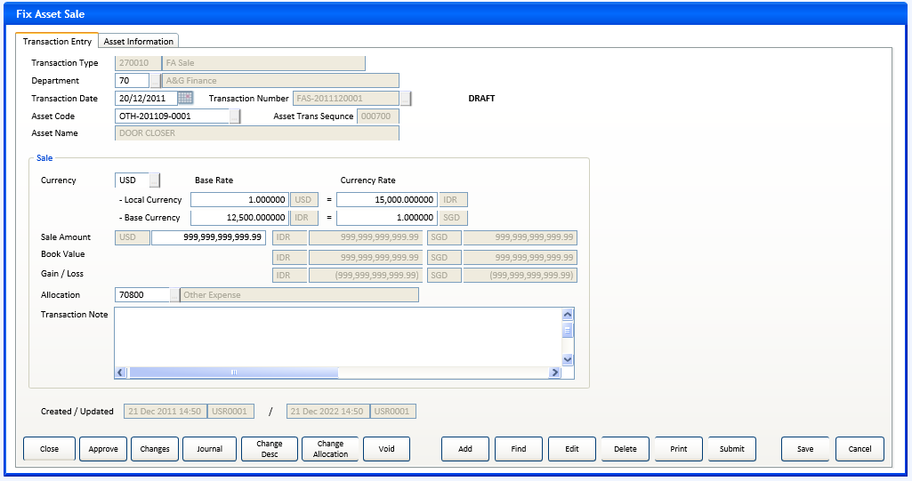
Form 1 Page 2 : FA Sale – Asset Information
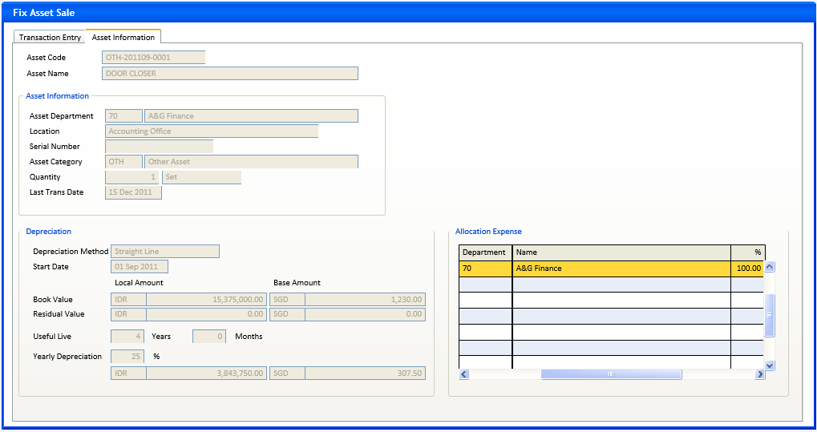

Form 1 Page 1 : FA Sale - Transaction Entry – change description
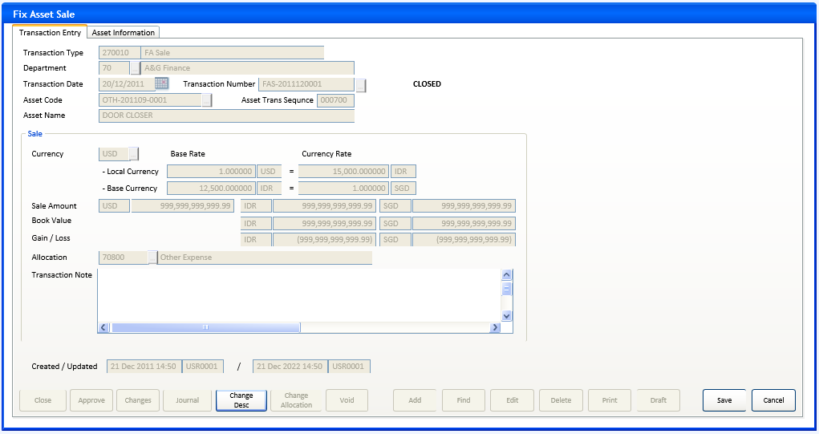
Form 1 Page 1 : FA Sale - Transaction Entry – change allocation
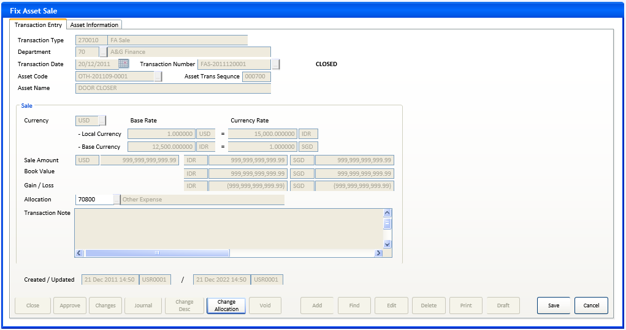
Form 1 Page 1 : FA Sale - Transaction Entry – inquiry
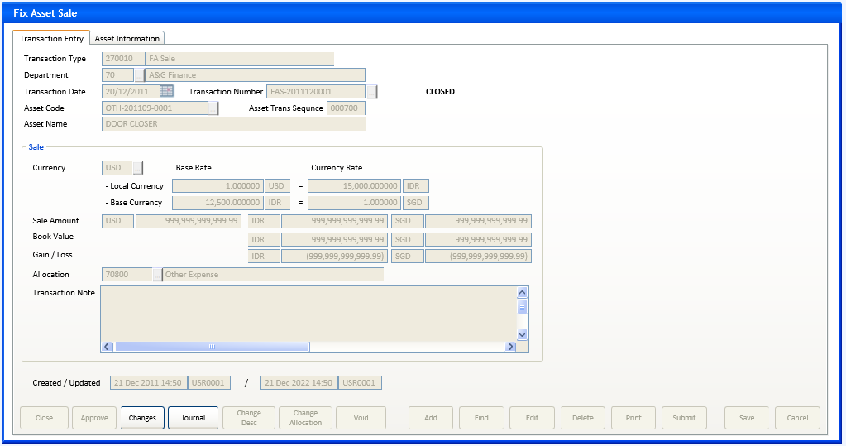

INITIAL PROCESS
Form 1 – FA Sale
- Parameter from calling program: @PCMODE, @PCASSET_CODE, @PCDEPT_CODE, @PCREFERENCE_NO
- Get FA Period and other parameters from FA System table
SELECT @CDEFAULT_TRX_DEPT_CODE = CTRANS_DEPT_CODE,
@CSOFT_PERIOD = CSOFT_PERIOD,
@CCURRENT_PERIOD = CCURRENT_PERIOD, --CR1
@CGLLINK_DATE = CGLLINK_DATE,
@CRATETYPE_CODE = CRATETYPE_CODE
FROM FAM_SYSTEM (nolock)
WHERE CCOMPANY_ID={login_company_id}
- @CTRANS_CODE = ’270010’
@PCMODE = if @PCMODE = ’’ then ’T’ run from menu will be Transaction mode
- Get Local and Base Currency

SELECT @CLOCAL_CURRENCY_CODE = CLOCAL_CURRENCY_CODE,
@CBASE_CURRENCY_CODE = CBASE_CURRENCY_CODE,
@LCUST_PERIOD_FLAG = LCUST_PERIOD_FLAG
FROM HSM_PROPERTY_SYSTEM (nolock)
WHERE CCOMPANY_ID={login_company_id}
- Get FA Transaction Type description, approval flag, and numbering setting (manual or auto increment)
SELECT @CTRANS_DESC = ISNULL(b.CDESCRIPTION,a.CTRANSACTION_NAME),
@LTRANS_APPROVAL = LAPPROVAL_FLAG,
@LINCREMENT_FLAG = LINCREMENT_FLAG
From GSM_TRANSACTION_CODE a (nolock)
LEFT JOIN GSB_TRANSLATE b (nolock) ON b.CTABLE_NAME =’GSM_TRANSACTION_CODE’ AND
B.CFOREIGN_LANGUAGE={login_user_Lang_id} AND B.CKEY_ID=a.CCOMPANY_ID + a.CTRANSACTION_CODE
Where a.CCOMPANY_ID={login_company_id} AND CTRANSACTION_CODE=@CTRANS_CODE
- Get user right for approval :
@LCAN_APPROVE = 0
SELECT @LCAN_APPROVE = 1
FROM FAM_APPROVAL_USER (nolock)
WHERE CCOMPANY_ID={login_company_id} AND CTRANSACTION_CODE=@CTRANS_CODE AND
CUSER_ID={login_user_Id}
- Get User Activity Rights :
SET @LCAN_CLOSE=0
SELECT @LCAN_CLOSE=1
FROM GSM_USER_RIGHT (nolock)
WHERE CCOMPANY_ID={login_company_id} AND CACTIVITY_CODE=’FA013001’ AND CUSER_ID={login_user_id}

- Set @LCHANGE_DESC = 0, @LCHANGE_ALLOC = 0
- Set default value of Transaction Type code and description fields.
- If @PCASSET_CODE <> ’’
then set default value of Asset Code and refresh Asset Name field
disable Asset Code and its lookup
go into normal mode
- If @PCREFERENCE_NO <> ’’
then set default value of Department code and refresh description field
set default value of Transaction Number
disable Department code and its lookup
disable Transaction Number and its lookup
do Display Process to retrieve and display data
go into normal mode

BUTTON DEFINITION
Form 1 - FA Sale | Test
- Lookup Department
- Enabled in Add mode or Find mode
- Run Prog GSL00500, with parameter {login_company_id}, {login_user_lang_id}, 1
- Return value to Department code and description

- Lookup Asset Code
- Enabled in Add mode, Edit mode when @LCHANGE_DESC=0 and @LCHANGE_ALLOC=0, or Find mode when @PCASSET_CODE=’’
- Run Prog FAL00500 with parameter :
when in Add or Edit mode {login_company_id}, ’’, 0, 1, 1, 0, 0
when in Find mode {login_company_id}, ’’, 0, 1, 1, 1, 1
- Return value to Asset code, Asset Name
- Set some variables value (see Display Process)

- Lookup Transaction Number
- Enabled in Find mode
- Run Prog FAL01000 with parameter {login_company_id}, {Department code}, ’270010’, {Asset code}, {login_user_lang_id}
- Return value to Department code, Transaction Number, and Asset Code
Refresh Department description and Asset Name

- Lookup Currency
- Enabled in Add mode or edit mode when @LCHANGE_DESC=0 and @LCHANGE_ALLOC=0
- Run Prog HSL51200 with no parameter
- Return value to Currency code

- Lookup Allocation
- Enabled in Add mode or Edit mode when @LCHANGE_DESC=0
- Run Prog ICL00300 with parameter {login_company_id}
- Return value to Allocation code and description

- Add
- Enabled in Normal mode when @PCMODE = ’T’ and @PCREFERENCE_NO=’’
- If @PCASSET_CODE<>’’ then validate not exists in :
SELECT CASSET_CODE
FROM FAT_TRANS_ASSET a (nolock), FAM_ASSET b (nolock)
WHERE a.CCOMPANY_ID={login_company_id} AND a.CASSET_CODE = {@PCASSET_CODE} and
a.LDELETE_FLAG=0 AND b.CCOMPANY_ID=a.CCOMPANY_ID AND b.CASSET_CODE=a.CASSET_CODE
AND a.CASSET_TRANS_SEQNO > b.CLSEQUENCE_NO
Message : This asset has outstanding transaction. Please settle it first

- Enable-disable input fields in the page (see Display Process)
- Enable-disable buttons in the page (see Button Definition)
- Disable all input fields and buttons outside the page (if any)
- Enter to Add mode
- Find
- Enabled in Normal mode when @PCREFERENCE_NO=’’, also enable in Find mode itself.
- If clicked in Normal mode :
  - Disable all input fields in the page except for Department code, Transaction Number, and Asset Code (if @PCASSET_CODE=’’)
  - Disable all buttons except for button Find itself, Department lookup, Transaction Number lookup, and Asset Code lookup (if @PCASSET_CODE=’’)
  - Disable all input fields and buttons outside the page (if any)
  - Clear value of all fields in the page except for Transaction Type code and description.
  - Set and display Department code with its default value and refresh its description
  - Set and display Asset code with its default value (@PCASSET_CODE) and refresh Asset Name
  - Enter to Find mode user can input Department code, Asset Code, Transaction Number and their lookups, then click Find button to get data
- If clicked in Find mode :
  - Get and display data by using entered key fields (see Display Process)
If data not found then nothing to do, all the fields remain empty/cleared.
  - Back into Normal mode
- Disable all input fields and lookup buttons in the page (see Display Process)
- Enable-disable buttons in the page (see Button Definition)

- Edit
- Enabled in Normal mode when any active (displayed) data, and @PCMODE = ’T’ and CSTATUS=’00’
- Enable-disable input fields in the page (see Display Process)
- Enable-disable button in the page (see Button Definition)
- Disable all input fields and buttons outside the page (if any)
- Enter to Edit mode

- Delete
- Enabled in Normal mode when any active (displayed) data, and @PCMODE=’T’ and CSTATUS=’00’ or ’01’ --CR2
- Confirmation : ’You can not undo delete. Are you sure to delete this transaction ?’ (Yes/No)
- If ‘Yes’ then do RSP_FAT_DELETE with parameters : {login_company_id}, {Department code}, {Transaction Type code}, {Transaction Number}, {login_user_id}
- Back to form and refresh

- Print
- Enabled on Normal mode when any active data and depend on user access right for printing
- Run FAR00010 Print FA Transaction to print current data with parameter {login_company_id}, {CDEPT_CODE}, {@CTRANS_CODE}, {CREFERENCE_NO}, {login_user_id}, {login_language_ID}
- Draft/Submit
- Enabled on Normal mode when any active (displayed) data and @PCMODE = ’T’ and (CSTATUS IN(’00’,’01’) or (CSTATUS=’03’ and @LTRANS_APPROVAL = 0)),
- If CSTATUS=’00’ then caption = ’Submit’ else ’Draft’
- If CSTATUS=’00’ then confirm : ’Are you sure to change to submit for this transaction ?’
else confirm : ’Are you sure to change to draft for this transaction ?’
(Yes/No)
- If ’Yes’ then do RSP_FAT_SUBMIT with parameters : {login_company_id}, {Department code}, {Transaction Type code}, {Transaction Number}, {login_user_id}
- Back to form and refresh
- Save
- Enabled on Add or Edit mode
- Do VALIDATE TRANSACTION, if not valid then back to form
- Do SAVE TRANSACTION
- Back to Normal mode

- Cancel
- Enabled on Add or Edit mode
- Cancel data input and restore field’s value
- Back to normal mode

- Close
- Enable on normal mode when any active data and @PCMODE = ’T’, @LCAN_CLOSE=1 AND (CSTATUS=’03’ or (CSTATUS=’01’ AND @LTRANS_APPROVAL=0))
- Validate GL Accounts available : --CR2
Do RSP_FA_VALIDATE_JOURNAL with parameters : {login_company_id}, {Department code}, {Transaction Type code}, {Transaction Number}
Message : GL account for journal is not available
- Confirmation : ’Please be aware, you can not modify this transaction anymore after this process’ (Process/Cancel)
- If ’Process’ then do RSP_FAT_CLOSE with parameters : {login_company_id}, {Department code}, {Transaction Type code}, {Transaction Number}, {login_user_id}
- Back to form and refresh
- Approve
- Enabled when any active data and @PCMODE = ’T’ and CSTATUS IN(’01’,’02’) and @LTRANS_APPROVAL=1 and @LCAN_APPROVE=1
- Do RSP_FAT_APPROVE with parameters : {login_company_id}, {Department code}, {Transaction Type code}, {Transaction Number}, {login_user_id}
- Back to form and refresh
- Void
- Enabled on Normal mode when any active data and @PCMODE=’T’ and CSTATUS=’08’ and CTRANSACTION_PRD >= @CSOFT_PERIOD and CASSET_TRANS_SEQNO = {@CLSEQUENCE_NO} and (LGLLINK=0 or CGL_TRF_STATUS = ’0’)
- Validate the asset have no next transaction should be not found in :
SELECT TOP 1 CASSET_CODE
FROM FAT_TRANS_ASSET (nolock)
WHERE CCOMPANY_ID={login_company_id} AND CASSET_CODE={Asset Code} AND
CASSET_TRANS_SEQNO > {Asset Trans Sequence} and LDELETE_FLAG=0 --CR4
Message : Can not Void transaction of asset already has the next one.
- Do FAT02100 with parameter : {login_company_id}, ’1201’, {login_language_id}
Save return value to @CCANCEL_REASON_CODE varchar(8)
If @CCANCEL_REASON_CODE=’’ then back to form
- Do APPROVAL_PRECHECK parameter ’FA013002’
If returned 1 (need approval)
then Do GST01100 (Approval) with parameter {login_company_id}, ’FA013002’
Save return value to @CCANCEL_APPROVED_BY varchar(8)
If @CCANCEL_APPROVED_BY=’’ then back to form

- Do RSP_FAT_VOID with parameters : {login_company_id}, {Department code}, {Transaction Type code}, {Transaction Number}, {login_user_id}, @CCANCEL_REASON_CODE, @CCANCEL_APPROVED_BY
- Back to form and refresh

- Changes
- Enable in normal mode when any active data
- Run GSI00200 with parameter : 1, {login_company_id}, ’FAT00800’, ’FAT_TRANS_HD’
- Journal
- Enable in normal mode when any active data and CSTATUS = ’08’
- Run program FAI00020 (FA Transaction Journal) with parameter : {login_company_id}, {Department code}, {Transaction Type code}, {Transaction Number}
- Back to form
- Change Desc
- Enable in normal mode when any active data and @PCMODE = ’T’ and CSTATUS not in (’00’,’09’,’98’,’99’)
- Enable Transaction Note input fields in the input form
- Disable all input fields and button outside the input form, except for Save and Cancel button should be enabled
- Set @LCHANGE_DESC = 1
- Enter to Edit mode
- Restore @LCHANGE_DESC = 0

- Change Allocation
- Enable in normal mode when any active data and @PCMODE = ’T’ and CSTATUS not in (’00’,’09’,’98’,’99’) and (CGL_TRF_STATUS=0 or LGLLINK=0)
- Enable Allocation code input fields in the input form
- Disable all input fields and button outside the input form, except for Save and Cancel button should be enabled
- Set @LCHANGE_ALLOC = 1
- Enter to Edit mode
- Restore @LCHANGE_ALLOC = 0

OUTPUT
Test
- None

DISPLAY PROCESS
Form 1 - FA Sale – Transaction Entry page
    - This page is used to input new transaction data or view existing one for next other activities

- Query to fill page fields based on key fields Department code and Transaction Number come from parameter @PCDEPT_CODE and @PCREFERENCE_NO or entered by user thru Find mode :
SELECT a.CDEPT_CODE,a.CREFERENCE_NO, a.CTRANSACTION_DATE, a.CTRANSACTION_DESCR, CSTATUS, LGLLINK, CGL_TRF_STATUS,
CCURRENCY_CODE, NLBASE_RATE_AMOUNT, NLCURRENCY_RATE_AMOUNT, a.NBBASE_RATE_AMOUNT,
a.NBCURRENCY_RATE_AMOUNT, a.CCREATE_BY, a.DCREATE_DATE, a.CUPDATE_BY, a.DUPDATE_DATE,
CSTATUS_DESC=ISNULL(p.DESCRIPTION, a.CSTATUS), CALLOC_EXPENSE_CODE,
CASSET_CODE, CASSET_TRANS_SEQNO, NTRANSACTION_AMOUNT1, NLTRANSACTION_AMOUNT1, NBTRANSACTION_AMOUNT1
FROM FAT_TRANS_HD a (nolock)
INNER JOIN FAT_TRANS_ASSET b (nolock) ON b.CCOMPANY_ID=a.CCOMPANY_ID AND b.CDEPT_CODE=a.CDEPT_CODE
AND b.CTRANSACTION_CODE=a.CTRANSACTION_CODE AND b.CREFERENCE_NO=a.CREFERENCE_NO AND b.LDELETE_FLAG=0 --CR4
LEFT JOIN RFT_GET_GSB_CODE_INFO('RHAPSODY', {login_company_id}, ’_TRX_STATUS’, ’’,
{login language id}) p ON c.CODE=a.CSTATUS
WHERE a.CCOMPANY_ID={login_company_id} AND a.CTRANSACTION_CODE={Transaction Type code} AND
a.CDEPT_CODE={Department code} AND a.CREFERENCE_NO={Transaction Number}

    - FIELD DEFINITION
  - Transaction Type code
    - Field : @CTRANS_CODE varchar(6) see Initial Process
    - Always disabled

  - Transaction Type description
    - Field : @CTRANS_DESC nvarchar(60) see Initial Process
    - Always disabled
  - Department code
    - Field : CDEPT_CODE varchar(8)
    - Enabled in Add mode or Find mode
    - Default value : @CDEFAULT_TRX_DEPT_CODE see Initial Process
    - Validate not empty
Message : Please enter a Department code
    - Use lookup validation
    - If {lookup.LEVERYONE_FLAG} = 0 then Validate found in :
Select * From GSX_DEPARTMENT_USER (nolock)
Where CCOMPANY_ID = {login_company_id} and CDEPT_CODE={Department code}
AND CUSER_ID = {login_user_id}
Message : You have no rights to access this Department
  - Department name
    - Field : {lookup description} nvarchar(60)
    - Always Disabled
  - Transaction Date
    - Field : CTRANSACTION_DATE char(8) display in date format
    - Enabled in Add mode
    - Default value = {property date}
    - If @LCUST_PERIOD_FLAG = 0
then @CPRD=LEFT({Transaction Date},6)
else SELECT @CPRD=CCYEAR+CPERIOD_NO FROM GSM_PERIOD_DT (nolock)
WHERE CCOMPANY_ID={login CCOMPANY_ID} and {Transaction Date} BETWEEN
CSTART_DATE AND CEND_DATE
    - Validation : @CPRD >= @SOFT_PERIOD
Message : Transaction date should be not less than the soft period
    - Validation : CTRANSACTION_DATE <= {property date}
Message : Transaction date should be not greater than today
    - Validation : LEFT(@CPRD,4) = LEFT(@CCURRENT_PERIOD,4) --CR1
Message : Transaction date should be in the year of current period

  - Transaction No
    - Field : CREFERENCE_NO varchar(30)
    - Enabled in Add mode when @LINCREMENT_FLAG=0 (manual numbering), also enabled in Find mode
    - If Add mode and @LINCREMENT_FLAG=1 (not manual numbering), then get CREFERENCE_NO after Save button clicked, then display on this textbox
  - Asset code
    - Field : CASSET_CODE varchar(20)
    - Default value : @PCASSET_CODE
    - Enable on Add mode, Edit mode when @LCHANGE_DESC=0 and @LCHANGE_ALLOC=0, or Find mode when @PCASSET_CODE=’’
    - Using lookup validation
    - SELECT @NLBOOKVAL = NLBOOK_VALUE - NLREVALUATION_AMT + NLPRIOR_REVALUATION_AMT + NLYTD_REVALUATION_AMT,
@NBBOOKVAL = NBBOOK_VALUE - NBREVALUATION_AMT + NBPRIOR_REVALUATION_AMT + NBYTD_REVALUATION_AMT
FROM FAM_ASSET (nolock)
WHERE CCOMPANY_ID={login_company_id} AND a.CASSET_CODE={Asset Code}
    - Refresh Book Value local amount and base amount

  - Asset name
    - Field : {lookup.description} nvarchar(60)
    - Always disabled

  - Asset Trans Sequence
    - Field : CASSET_TRANS_SEQNO nvarchar(60)
    - Default value = {lookup.CNSEQUENCE_NO}
    - Always disabled

  - (status)
    - Field : CSTATUS_DESC nvarchar(15)
    - Default value = ’DRAFT’
    - Always disabled

  - Currency
    - Field : CCURRENCY_CODE varchar(3)
    - Default value = @CLOCAL_CURRENCY_CODE
    - Enabled on add mode or edit mode when @LCHANGE_DESC=0 and @LCHANGE_ALLOC=0
    - Synchronize currency code of : Local Currency-Base Rate, Base Currency-Base Rate
    - If user change the Currency :
    - Do RSP_GET_CURRENCY_RATE parameter : {login_company_id}, {Currency}, @CRATETYPE_CODE, {Transaction Date}, @NLBASE_RATE_AMOUNT output, @NBBASE_RATE_AMOUNT output, @NLCURRENCY_RATE_AMOUNT output, @NBCURRENCY_RATE_AMOUNT output
    - Store output variables to field NLBASE_RATE_AMOUNT, NLCURRENCY_RATE_AMOUNT, NBBASE_RATE_AMOUNT and NBCURRENCY_RATE_AMOUNT
    - Set default value for amount of : Local Currency-Base Rate, Local Currency-Currency Rate, Base Currency-Base Rate, Base Currency-Currency Rate
    - If CCURRENCY_CODE = @CLOCAL_CURRENCY_CODE then disable the amount of : Local Currency-Base Rate, Local Currency-Currency Rate
    - If CCURRENCY_CODE = @CBASE_CURRENCY_CODE or @CLOCAL_CURRENCY_CODE = @CBASE_CURRENCY_CODE
then disable the amount of : Base Currency-Base Rate, Base Currency-Currency Rate
  - Local Currency - Base Rate - currency code
    - Field : CCURRENCY_CODE varchar(3)
    - Synchronized at Currency lost focus
    - Always disabled

  - Local Currency - Base Rate - amount
    - Field : NLBASE_RATE_AMOUNT numeric 6 decimal, value > 0.000000
    - Synchronized at Currency lost focus
    - Enabled on add mode or edit mode when @LCHANGE_DESC=0 and @LCHANGE_ALLOC=0 and CCURRENCY_CODE <> @CLOCAL_CURRENCY_CODE
    - If @CLOCAL_CURRENCY_CODE = @CBASE_CURRENCY_CODE then refresh Base Currency - Base Rate - amount

  - Local Currency - Currency Rate - currency code
    - Field : @CLOCAL_CURRENCY_CODE varchar(3)
    - Always disabled

  - Local Currency - Currency Rate - amount
    - Field : NLCURRENCY_RATE_AMOUNT numeric 6 decimal, value > 0.000000
    - Synchronized at Currency lost focus
    - Enabled on add mode or edit mode when @LCHANGE_DESC=0 and @LCHANGE_ALLOC=0 and CCURRENCY_CODE <> @CLOCAL_CURRENCY_CODE
    - If @CLOCAL_CURRENCY_CODE = @CBASE_CURRENCY_CODE then refresh Base Currency - Currency Rate - amount

  - Base Currency - Base Rate - currency code
    - Field : CCURRENCY_CODE varchar(3)
    - Synchronized at Currency lost focus
    - Always disabled

  - Base Currency - Base Rate - amount
    - Field : NBBASE_RATE_AMOUNT numeric 6 decimal, value > 0.000000
    - Synchronized at Currency lost focus
    - Enabled on Add mode or edit mode when @LCHANGE_DESC=0 and @LCHANGE_ALLOC=0 and CCURRENCY_CODE <> @CBASE_CURRENCY_CODE and @CLOCAL_CURRENCY_CODE <> @CBASE_CURRENCY_CODE
    - If @CLOCAL_CURRENCY_CODE = @CBASE_CURRENCY_CODE then set value = {Local Currency-Base Rate–amount}

  - Base Currency - Currency Rate - currency code
    - Field : @CBASE_CURRENCY_CODE varchar(3)
    - Always disabled

  - Base Currency - Currency Rate - amount
    - Field : NBCURRENCY_RATE_AMOUNT numeric 6 decimal, value > 0.000000
    - Synchronized at Currency lost focus
    - Enabled on Add mode or edit mode when @LCHANGE_DESC=0 and @LCHANGE_ALLOC=0 and CCURRENCY_CODE <> @CBASE_CURRENCY_CODE and @CLOCAL_CURRENCY_CODE <> @CBASE_CURRENCY_CODE
    - If @CLOCAL_CURRENCY_CODE = @CBASE_CURRENCY_CODE then set value = {Local Currency-Currency Rate–amount}
  - Sale Amount original currency
    - Field : CCURRENCY_CODE varchar(3)
    - Synchronized at Currency lost focus
    - Always disabled

  - Sale Amount original amount
    - Field : NTRANSACTION_AMOUNT1 numeric 2 decimal
    - Default value in add mode : 0.00
    - Enabled on Add mode or edit mode when @LCHANGE_DESC=0 and @LCHANGE_ALLOC=0
    - Refresh Sale Amount local amount and Sale Amount base amount
  - Sale Amount local currency
    - Field : @CLOCAL_CURRENCY_CODE varchar(3)
    - Always disabled

  - Sale Amount local amount
    - Field : NLTRANSACTION_AMOUNT1 numeric 2 decimal
    - Always disabled
    - Recalculated value : ROUND({Sale Amount original amount} * {NLCURRENCY_RATE_AMOUNT} / {NLBASE_RATE_AMOUNT}, 2)
    - Refresh Gain/Loss local amount
  - Sale Amount base currency
    - Field : @CBASE_CURRENCY_CODE varchar(3)
    - Always disabled

  - Sale Amount base amount
    - Field : NBTRANSACTION_AMOUNT1 numeric 2 decimal
    - Always disabled
    - Recalculated value : ROUND({Sale Amount original amount} * {NBCURRENCY_RATE_AMOUNT} / {NBBASE_RATE_AMOUNT}, 2)
    - Refresh Gain/Loss base amount

  - Book Value local currency
    - Field : @CLOCAL_CURRENCY_CODE varchar(3)
    - Always disabled

  - Book Value local amount
    - Field : @NLBOOKVAL numeric 2 decimal
    - Always disabled
    - Refresh Gain/Loss local amount

  - Book Value base currency
    - Field : @CBASE_CURRENCY_CODE varchar(3)
    - Always disabled

  - Book Value base amount
    - Field : @NBBOOKVAL numeric 2 decimal
    - Always disabled
    - Refresh Gain/Loss base amount

  - Gain/Loss local currency
    - Field : @CLOCAL_CURRENCY_CODE varchar(3)
    - Always disabled

  - Gain/Loss local amount
    - Field : {Sale Amount local amount} – {Book Value local amount}
    - Always disabled

  - Gain/Loss base currency
    - Field : @CBASE_CURRENCY_CODE varchar(3)
    - Always disabled

  - Gain/Loss base amount
    - Field : {Sale Amount base amount} – {Book Value base amount}
    - Always disabled

  - Allocation code
    - Field : CALLOC_EXPENSE_CODE varchar(8)
    - Enabled in Add mode or Edit mode when @LCHANGE_DESC=0
    - Use lookup validation

  - Allocation description
    - Field : {lookup description} nvarchar(60)
    - Always Disabled
  - Transaction Note
    - Field : CTRANSACTION_DESCR nvarchar(300), using multi lines edit box
    - Enabled on Add mode and edit mode when @LCHANGE_ALLOC=0

  - Created
    - Field : DCREATE_DATE datetime
CCREATE_BY varchar(8)
    - Always disabled

  - Updated
    - Field : DUPDATE_DATE datetime
CUPDATE_BY varchar(8)
    - Always disabled

Form 1 - FA Sale – Asset Information page
- This page contains detail data of Asset Code in Transaction Entry page
All fields on this page are read only
- Query to fill Asset Info page fields
SELECT CASSET_CODE, CASSET_NAME, CSERIAL_NUMBER, CASSET_DEPT_CODE, CASSET_LOCATION, CCATEGORY_CODE,
CDEPR_METHOD, CSTART_DATE, NLBOOK_VALUE, NBBOOK_VALUE, NYEAR_DEPR_PCT,
NLYEAR_DEPR_AMT, NBYEAR_DEPR_AMT, NLRESIDUAL_VALUE, NBRESIDUAL_VALUE,
IQTY = IBEGINNING_QTY - IADDITION_QTY - IDEDUCTION_QTY, CUNIT, CLAST_TRANS_DATE,
IUSEFUL_LIVE_YR = FLOOR(a.IUSEFUL_LIVE / 12), IUSEFUL_LIVE_MO = MOD(a.IUSEFUL_LIVE / 12),
CASSET_DEPT_NAME = ISNULL(b.CDESCRIPTION,’’),
CCATEGORY_DESC=ISNULL(c1.CDESCRIPTION, c.CCATEGORY_DESC)
CDEPR_METHOD_DESC = ISNULL(d.CDESCRIPTION,’’),
FROM FAM_ASSET a (nolock)
LEFT JOIN RFT_GET_GSB_CODE_INFO('RHAPSODY', {login_company_id}, ’_DEPARTMENT’,’’,
{login language id}) b ON b.CODE = CASSET_DEPT_CODE
LEFT JOIN GSM_CATEGORY c (nolock) ON c.CCOMPANY_ID=a.CCOMPANY_ID and CCATEGORY_ITEM=’51’ and
CCATEGORY_TYPE=’C’ and c.CCATEGORY_CODE=a.CCATEGORY_CODE
LEFT JOIN GSM_TRANSLATE c1 (nolock) ON c1.CTABLE_NAME=’GSM_CATEGORY’ AND c1.CFOREIGN_LANGUAGE=
{login language id} AND c1.CKEY_ID = c.CCOMPANY_ID + c.CCATEGORY_ITEM + c.CCATEGORY_TYPE +
c.CCATEGORY_CODE
LEFT JOIN RFT_GET_GSB_CODE_INFO('RHAPSODY',{login_company_id},’_FA_DEPR_METHOD’,'',
{login language id}) d ON d.CODE = a.CDEPR_METHOD
WHERE a.CCOMPANY_ID={login_company_id} AND a.CASSET_CODE={Transaction Entry.Asset Code}
    - FIELDS DEFINITION
All fields on this page are read only
  - Asset Code
    - Field : CASSET_CODE varchar(20)

  - Asset Name
    - Field : CASSET_NAME nvarchar(60)

  - Asset Department code
    - Field : CASSET_DEPT_CODE varchar(8)

  - Asset Department name
    - Field : CASSET_DEPT_NAME nvarchar(60)
  - Location
    - Field : CASSET_LOCATION nvarchar(60)

  - Serial Number
    - Field : CSERIAL_NUMBER varchar(30)

  - Asset Category code
    - Field : CCATEGORY_CODE varchar(6)

  - Asset Category description
    - Field : CCATEGORY_DESC nvarchar(60)

  - Quantity
    - Field : ITRANSACTION_QTY1 integer, CUNIT varchar(6)

  - Last Trans Date
    - Field : CLAST_TRANS_DATE char(8), display with date format

  - Depreciation Method
    - Field : CDEPR_METHOD_DESC nvarchar(20)

  - Start Date
    - Field : CSTART_DATE varchar(8), display with date format

  - Book Value
    - Field : @CLOCAL_CURRENCY_CODE varchar(3)
NLBOOK_VALUE numeric 2 decimal
@CBASE_CURRENCY_CODE varchar(3)
NBBOOK_VALUE numeric 2 decimal

  - Residual Value
    - Field : @CLOCAL_CURRENCY_CODE varchar(3)
NLRESIDUAL_VALUE numeric 2 decimal
@CBASE_CURRENCY_CODE varchar(3)
NBRESIDUAL_VALUE numeric 2 decimal

  - Residual Value – Base Amount
    - Field : NBRESIDUAL_VALUE numeric 2 decimal
    - Always disabled
    - Recalculated value : ROUND({header.NBXRATE} * {Residual Value Local Amount},2)

  - Useful Live - years
    - Field : IUSEFUL_LIVE_YR smallint

  - Useful Live - months
    - Field : IUSEFUL_LIVE_MO smallint
  - Yearly Depreciation
    - Field : NYEAR_DEPR_PCT numeric 5,2 decimal
@CLOCAL_CURRENCY_CODE varchar(3)
NLYEAR_DEPR_AMT numeric 2 decimal
@CBASE_CURRENCY_CODE varchar(3)
NBYEAR_DEPR_AMT numeric 2 decimal

- Query to fill grid Allocation Expense

SELECT CEXPENSE_DEPT_CODE, NEXPENSE_PCT, CEXPENSE_DEPT_NAME = isnull(y.DESCRIPTION,’’)
FROM FAM_ASSET_EXP_ALLOC a (nolock)
LEFT JOIN RFT_GET_GSB_CODE_INFO('RHAPSODY', {login_company_id},’_DEPARTMENT’,'',{login language id}) y
on y.CODE = a.CEXPENSE_DEPT_CODE
WHERE a.CCOMPANY_ID={login_company_id} AND a.CASSET_CODE={Asset Code}
- Default display order by CEXPENSE_DEPT_CODE, go top record

    - GRID COLUMN DEFINITION
This is read only grid
  - Department
    - Field : CEXPENSE_DEPT_CODE varchar(8)

  - Name
    - Field : CEXPENSE_DEPT_NAME nvarchar(60)
  - %
    - Field : NEXPENSE_PCT numeric 2 decimal

VALIDATE TRANSACTION
For Add Mode ( New ) and Edit Mode
  - Validation :
    - {Department code} <> ’’
Message : Department code should not be empty
    - {Transaction Date} <> ’’
Message : Transaction Date should not be empty
    - {Asset code} <> ’’
Message : Asset code should not be empty
    - {Currency} <> ’’
Message : Currency code should not be empty
    - {Allocation} <> ’’
Message : Allocation code should not be empty
- {Sale Amount} > 0.00
Message : Please enter a valid sale Amount
- {Local Currency Base Rate amount} <> 0 and {Local Currency Currency Rate amount} <> 0
{Base Currency Base Rate amount} <> 0 {Base Currency Currency Rate amount} <> 0
Message : Please enter a valid currency rate
- If Add mode then validate not found in :
SELECT CASSET_CODE
FROM FAT_TRANS_ASSET a (nolock), FAM_ASSET b (nolock)
WHERE a.CCOMPANY_ID={login_company_id} AND a.CASSET_CODE = {Asset Code} and
a.LDELETE_FLAG=0 AND b.CCOMPANY_ID=a.CCOMPANY_ID AND b.CASSET_CODE=a.CASSET_CODE
AND a.CASSET_TRANS_SEQNO > b.CLSEQUENCE_NO
UNION --CR3
SELECT a.CASSET_CODE
FROM FAT_RAPID_DISCARD_ASSET a (nolock), FAT_RAPID_DISCARD_HD c (nolock),FAM_ASSET b (nolock)
WHERE a.CCOMPANY_ID={login_company_id} AND a.CASSET_CODE = {Asset Code} and
c.CCOMPANY_ID=a.CCOMPANY_ID AND c.CDEPT_CODE=a.CDEPT_CODE AND c.CTRANSACTION_CODE=
a.CTRANSACTION_CODE and c.CREFERENCE_NO=a.CREFERENCE_NO and c.CSTATUS<=’08’ AND
b.CCOMPANY_ID=a.CCOMPANY_ID AND b.CASSET_CODE=a.CASSET_CODE AND
a.CASSET_TRANS_SEQNO>b.CLSEQUENCE_NO
Message : This asset has outstanding transaction. Please settle it first.

    - SELECT @CLAST_TRANS_DATE = CLAST_TRANS_DATE,
@CASSET_STATUS = CASSET_STATUS
FROM FAM_ASSET (nolock)
WHERE CCOMPANY_ID={login_company_id} AND CASSET_CODE = {Asset Code}
    - (Edit Mode and (@LCHANGE_DESC=1 or @LCHANGE_ALLOC=1)) or @CASSET_STATUS in (’1’,’2’)
Message : Status of the asset is not allowed for adding this transaction
    - {Transaction Date} >= @CLAST_TRANS_DATE
Message : Transaction Date should not be before the last one of this asset

    - If Add Mode and @LINCREMENT_FLAG=0 then validate :
      - {Transaction Number}<>’’ Message : Transaction Number should not be empty
      - Not exists(select * from FAT_TRANS_HD (nolock) where CCOMPANY_ID = {login_company_id}
and CDEPT_CODE={Department code} and CTRANSACTION_CODE={Transaction Type} and
CTRANSACTION_NO={Transaction Number})
Message : Transaction Number is already exists.

SAVE TRANSACTION
Preparation | Test
  - Get Asset information :
SELECT @NLFA = NLBEGINNING_AMT + NLADDITION_AMT - NLDEDUCTION_AMT,
@NLAD = NLPRIOR_DEPR_AMT + NLYTD_DEPR_AMT,
@NLRFA = NLREVALUATION_AMT,
@NLRAD = NLPRIOR_REVALUATION_AMT + NLYTD_REVALUATION_AMT
@NBFA = NBBEGINNING_AMT + NBADDITION_AMT - NBDEDUCTION_AMT,
@NBAD = NBPRIOR_DEPR_AMT + NBYTD_DEPR_AMT,
@NBRFA = NBREVALUATION_AMT,
@NBRAD = NBPRIOR_REVALUATION_AMT + NBYTD_REVALUATION_AMT
@CNSEQUENCE_NO = right(’000000’ + convert(varchar(6),convert(integer,CLSEQUENCE_NO)+100),6),
@CASSET_DEPT_CODE = CASSET_DEPT_CODE,
@CJRNGRP_CODE = CJRNGRP_CODE,
@CTAX_CATEGORY_CODE = CTAX_CATEGORY_CODE,
@CDEPR_METHOD = CDEPR_METHOD
FROM FAM_ASSET (nolock)
WHERE CCOMPANY_ID={login_company_id} AND CASSET_CODE = {Asset Code}

  - Get Period :
SELECT @CPRD = CCYEAR + CPERIOD_NO
FROM GSM_PERIOD_DT
WHERE CCOMPANY_ID={login_company_id} AND {Transaction Date} BETWEEN CSTART_DATE AND CEND_DATE

Create Header Transaction for Add Mode
  - If @LINCREMENT_FLAG=1 then Run RSP_GET_REFNO parameter : {login_company_id}, {Transaction Type}, {Department code}, {Transaction Date}, {login_user_id}, @CREFERENCE_NO Output
  - Add Data Into FAT_TRANS_HD
    - CCOMPANY_ID = {login_company_id}
    - CDEPT_CODE = {Department code}
    - CTRANSACTION_CODE = {Transaction Type code}
    - CREFERENCE_NO = if @LINCREMENT_FLAG=0 then {Transaction Number} else @CREFERENCE_NO
    - CSUPPLIER_ID ignored
    - CINFO_SEQNO ignored
    - CSUPPLIER_NAME ignored
    - CTRANSACTION_DATE = {Transaction Date}
    - CTRANSACTION_PRD = @CPRD
    - CTRANSACTION_DESCR = {Transaction Note}
    - CDOCUMENT_DATE ignored
    - CDOCUMENT_NO ignored
    - CCURRENCY_CODE = {Currency}
    - CFR_MODULE ignored
    - CFR_DEPT_CODE ignored
    - CFR_TRANSACTION_CODE ignored
    - CFR_REFERENCE_NO ignored
    - NLBASE_RATE_AMOUNT = {Local Currency Base Rate amount}
    - NLCURRENCY_RATE_AMOUNT = {Local Currency Currency Rate amount}
    - NBBASE_RATE_AMOUNT = {Base Currency Base Rate amount}
    - NBCURRENCY_RATE_AMOUNT = {Base Currency Currency Rate amount}
    - NTRANSACTION_AMOUNT = {Sale Amount(original amount)}
    - NLTRANSACTION_AMOUNT = {Sale Amount(local amount)}
    - NBTRANSACTION_AMOUNT = {Sale Amount(base amount)}
    - CSTATUS = ’00’
    - LGLLINK = if @CGLLINK_DATE <= {Transaction Date} then 1 else 0
    - CGL_TRF_STATUS = 0
    - CGL_REFERENCE_NO = ’’
    - CAPPROVED_BY ignored
    - DAPPROVED_DATE ignored
    - CCOMMIT_BY ignored
    - DCOMMIT_DATE ignored
    - CCANCEL_REASON_CODE ignored
    - CCANCEL_APPROVED_BY ignored
    - CCANCEL_BY ignored
    - DCANCEL_DATE ignored
    - CCREATE_BY = {login_user_id}
    - DCREATE_DATE = {property date_time}
    - CUPDATE_BY = {login_user_id}
    - DUPDATE_DATE = {property date_time}
  - Add Data Into FAT_TRANS_ASSET
    - CCOMPANY_ID = {login_company_id}
    - CDEPT_CODE = {Department code}
    - CTRANSACTION_CODE = {Transaction Type code}
    - CREFERENCE_NO = if @LINCREMENT_FLAG=0 then {Transaction Number} else @CREFERENCE_NO
    - CASSET_CODE = {Asset Code}
    - CTRANS_SEQNO = ’000100’
    - CASSET_TRANS_SEQNO = @CNSEQUENCE_NO
    - CTRANSACTION_DATE = {Transaction Date}
    - NBBASE_RATE_AMOUNT ignored
    - NBCURRENCY_RATE_AMOUNT ignored
    - NTRANSACTION_AMOUNT1 = {Sale Amount(original amount)}
    - NTRANSACTION_AMOUNT2 = @NLFA
    - NTRANSACTION_AMOUNT3 = @NLAD
    - NTRANSACTION_AMOUNT4 = @NLRFA
    - NTRANSACTION_AMOUNT5 = @NLRAD
    - NTRANSACTION_AMOUNT6 ignored
    - NLTRANSACTION_AMOUNT1 = {Sale Amount(local amount)}
    - NLTRANSACTION_AMOUNT2 = @NLFA
    - NLTRANSACTION_AMOUNT3 = @NLAD
    - NLTRANSACTION_AMOUNT4 = @NLRFA
    - NLTRANSACTION_AMOUNT5 = @NLRAD
    - NLTRANSACTION_AMOUNT6 ignored
    - NBTRANSACTION_AMOUNT1 = {Sale Amount(base amount)}
    - NBTRANSACTION_AMOUNT2 = @NBFA
    - NBTRANSACTION_AMOUNT3 = @NBAD
    - NBTRANSACTION_AMOUNT4 = @NBRFA
    - NBTRANSACTION_AMOUNT5 = @NBRAD
    - NBTRANSACTION_AMOUNT6 ignored
    - ITRANSACTION_QTY1 ignored
    - ITRANSACTION_QTY2 ignored
    - CUNIT ignored
    - CALLOC_EXPENSE_CODE = {Allocation}
    - CFR_DEPT_CODE ignored
    - CFR_TRANSACTION_CODE ignored
    - CFR_REFERENCE_NO ignored
    - CFR_TRANSACTION_DATE ignored
    - CFR_SEQUENCE_NO ignored
    - CTRANSACTION_DESCR = {Transaction Note}
    - CASSET_DEPT_CODE = @CASSET_DEPT_CODE
    - CASSET_LOCATION ignored
    - CJRNGRP_CODE = @CJRNGRP_CODE
    - CTAX_CATEGORY_CODE = @CTAX_CATEGORY_CODE
    - CCATEGORY_CODE ignored
    - CSCATEGORY_CODE ignored
    - CDEPR_METHOD = @CDEPR_METHOD
    - CSTART_DATE ignored
    - NLBOOK_VALUE ignored
    - NBBOOK_VALUE ignored
    - IUSEFUL_LIVE ignored
    - NLYEAR_DEPR_AMT ignored
    - NBYEAR_DEPR_AMT ignored
    - NLRESIDUAL_VALUE ignored
    - NBRESIDUAL_VALUE ignored
    - NYEAR_DEPR_PCT ignored
    - COASSET_DEPT_CODE ignored
    - COASSET_LOCATION ignored
    - COJRNGRP_CODE ignored
    - COTAX_CATEGORY_CODE ignored
    - COCATEGORY_CODE ignored
    - COSCATEGORY_CODE ignored
    - CODEPR_METHOD ignored
    - COSTART_DATE ignored
    - NOLBOOK_VALUE ignored
    - NOBBOOK_VALUE ignored
    - IOUSEFUL_LIVE ignored
    - NOLYEAR_DEPR_AMT ignored
    - NOBYEAR_DEPR_AMT ignored
    - NOLRESIDUAL_VALUE ignored
    - NOBRESIDUAL_VALUE ignored
    - NOYEAR_DEPR_PCT ignored
    - IOTRANSACTION_QTY1 ignored
    - LDELETE_FLAG = 0
    - CDEPR_STATUS ignored
    - CCURRENT_PRD = @CPRD
    - CLLINK_FLAG ignored
    - CCREATE_BY = {login_user_id}
    - DCREATE_DATE = {property date_time}
    - CUPDATE_BY = {login_user_id}
    - DUPDATE_DATE = {property date_time}

Update Transaction for Edit Mode when @LCHANGE_DESC = 0 and @LCHANGE_ALLOC = 0 | Test
- Update FAT_TRANS_HD where CCOMPANY_ID={login_company_id} AND DEPT_CODE={Department code}
AND CTRANSACTION_CODE={Transaction Type code} and CREFERENCE_NO={Transaction Number}

    - CTRANSACTION_DATE = {Transaction Date}
    - CTRANSACTION_PRD = @CPRD
    - CTRANSACTION_DESCR = {Transaction Note}
    - CCURRENCY_CODE = {Currency}
    - NLBASE_RATE_AMOUNT = {Local Currency Base Rate amount}
    - NLCURRENCY_RATE_AMOUNT = {Local Currency Currency Rate amount}
    - NBBASE_RATE_AMOUNT = {Base Currency Base Rate amount}
    - NBCURRENCY_RATE_AMOUNT = {Base Currency Currency Rate amount}
    - NTRANSACTION_AMOUNT = {Sale Amount(original amount)}
    - NLTRANSACTION_AMOUNT = {Sale Amount(local amount)}
    - NBTRANSACTION_AMOUNT = {Sale Amount(base amount)}
    - LGLLINK = if @CGLLINK_DATE <= {Transaction Date} then 1 else 0
    - CUPDATE_BY = {login_user_id}
    - DUPDATE_DATE = {property date_time}

- Update FAT_TRANS_ASSET where CCOMPANY_ID={login_company_id} AND DEPT_CODE={Department code}
AND CTRANSACTION_CODE={Transaction Type code} and CREFERENCE_NO={Transaction Number}
AND CTRANS_SEQNO = ’000100’
    - CASSET_CODE = {Asset Code}
    - CASSET_TRANS_SEQNO = @CNSEQUENCE_NO
    - CTRANSACTION_DATE = {Transaction Date}
    - NTRANSACTION_AMOUNT1 = {Sale Amount(original amount)}
    - NTRANSACTION_AMOUNT2 = @NLFA
    - NTRANSACTION_AMOUNT3 = @NLAD
    - NTRANSACTION_AMOUNT4 = @NLRFA
    - NTRANSACTION_AMOUNT5 = @NLRAD
    - NLTRANSACTION_AMOUNT1 = {Sale Amount(local amount)}
    - NLTRANSACTION_AMOUNT2 = @NLFA
    - NLTRANSACTION_AMOUNT3 = @NLAD
    - NLTRANSACTION_AMOUNT4 = @NLRFA
    - NLTRANSACTION_AMOUNT5 = @NLRAD
    - NBTRANSACTION_AMOUNT1 = {Sale Amount(base amount)}
    - NBTRANSACTION_AMOUNT2 = @NBFA
    - NBTRANSACTION_AMOUNT3 = @NBAD
    - NBTRANSACTION_AMOUNT4 = @NBRFA
    - NBTRANSACTION_AMOUNT5 = @NBRAD
    - CALLOC_EXPENSE_CODE = {Allocation}
    - CTRANSACTION_DESCR = {Transaction Note}
    - CASSET_DEPT_CODE = @CASSET_DEPT_CODE
    - CJRNGRP_CODE = @CJRNGRP_CODE
    - CTAX_CATEGORY_CODE = @CTAX_CATEGORY_CODE
    - CDEPR_METHOD = @CDEPR_METHOD
    - CCURRENT_PRD = @CPRD
    - CUPDATE_BY = {login_user_id}
    - DUPDATE_DATE = {property date_time}

Update Transaction for Edit Mode when @LCHANGE_DESC = 1 | Test
- Update FAT_TRANS_HD where CCOMPANY_ID={login_company_id} AND DEPT_CODE={Department code}
AND CTRANSACTION_CODE={Transaction Type code} and CREFERENCE_NO={Transaction Number}

    - CTRANSACTION_DESCR = {Transaction Note}
    - CUPDATE_BY = {login_user_id}
    - DUPDATE_DATE = {property date_time}

- Update FAT_TRANS_ASSET where CCOMPANY_ID={login_company_id} AND DEPT_CODE={Department code}
AND CTRANSACTION_CODE={Transaction Type code} and CREFERENCE_NO={Transaction Number}

    - CTRANSACTION_DESCR = {Transaction Note}
    - CUPDATE_BY = {login_user_id}
    - DUPDATE_DATE = {property date_time}

Update Transaction for Edit Mode when @LCHANGE_ALLOC = 1 | Test
- Run RSP_FA_TRANSACTION_JOURNAL parameter : ’DELETE’, {login_company_id}, {Department code},
{Transaction Type code}, {Transaction Number}, {login_user_id}
- Update FAT_TRANS_ASSET where CCOMPANY_ID={login_company_id} AND DEPT_CODE={Department code}
AND CTRANSACTION_CODE={Transaction Type code} and CREFERENCE_NO={Transaction Number}

    - CALLOC_EXPENSE_CODE = {Allocation}
    - CUPDATE_BY = {login_user_id}
    - DUPDATE_DATE = {property date_time}

- Run RSP_FA_TRANSACTION_JOURNAL parameter : ’ADD’, {login_company_id}, {Department code},
{Transaction Type code}, {Transaction Number}, {login_user_id}

APPROVAL_PRECHECK
Test
PARAMETER @CAPPROVAL_CODE

SELECT IAPPVROVAL_OPTION
FROM GSM_ACTIVITY_APPROVAL (NOLOCK)
WHERE CCOMPANY_ID = {login_company_id} AND CAPPROVAL_CODE = @CAPPROVAL_CODE

If found and IAPPVROVAL_OPTION = 2 then return 1 (need approval) else 0 (approval not needed)

App Config

CR LIST
CR | DESCRIPTION | REQUEST BY
29 May 2023 | - Initial version
1 Jul 2023 CR1 | - Transaction date should be in the year of current period
29 Aug 2023 CR2 | - Button Delete should be disabled when CStatus<>’00’  - Validate GL Accounts should be available when transaction closed
21 Oct 2023 CR3 | - Add validation to table Rapid Discard Transaction
1 Dec 2023 CR4 | - Transaction data should be still shown when the transaction is deleted or voided

